Data Visualization

Project : Sales Insights

**Gowri Priya Pulagam - 11710373**

**Prem Gladstone Kanaparthi – 11710378**

**Manish Raghunathareddy – 11657375**

**Divyasree Sandineni – 11653172**

**Harshavardhan Thotakura - 117188**

**Revision History**

|  |  |  |  |
| --- | --- | --- | --- |
| **Revision Number** | **Date** | **Summary of Changes** | **Author(s)** |
| 1.0 | 09/22/2023 | Discussed how to do assignment and worked on Class Diagram, ER(Entity – Relationship) Diagram. Planed Class Diagram based on our project requirements. | Gowri Priya  Manish Raghunathareddy |
| 2.0 | 09/22/2023 | Discussed about the project logo and worked on sequence diagram. Everyone from team has given some inputs about how to make diagram . Also we worked on some terms that belong to diagram . | Gowri Priya  Prem Gladsyone Kanaparthi  Manish Raghunathareddy  Divyasree Sandineni  Harshavardhan Thotakura |
| 3.0 | 09/23/2023 | Finished working on Sequence Diagram and made changes to diagram , also done work related to Information Architecture Design. Everyone from team has given ideas about the design and we have completed working on Architecture Design. | Gowri Priya  Prem Gladsyone Kanaparthi  Manish Raghunathareddy  Divyasree Sandineni  Harshavardhan Thotakura |
| 4.0 | 09/23/2023 | Made some changes to previous work that we had done and worked on Design Rationale , User Interface Design screenshots. Worked on figma and UI diagram. | Manish Raghunathareddy  Divyasree Sandineni |
| 5.0 | 09/23/2023 | Worked on Dashboards and Charts. | Gowri Priya  Prem Gladsyone Kanaparthi  Manish Raghunathareddy  Divyasree Sandineni  Harshavardhan Thotakura |
| 6.0 | 09/24/2023 | Worked on Accessibility and Interactivity classes. | Gowri Priya  Prem Gladsyone Kanaparthi  Manish Raghunathareddy  Divyasree Sandineni  Harshavardhan Thotakura |
| 7.0 | 09/24/2023 | Worked on User Registration and Authentication. | Gowri Priya  Prem Gladsyone Kanaparthi  Manish Raghunathareddy  Divyasree Sandineni  Harshavardhan Thotakura |
| 8.0 | 09/24/2023 | Worked on Dashboard Creation and Customization. | Gowri Priya  Prem Gladsyone Kanaparthi  Manish Raghunathareddy  Divyasree Sandineni  Harshavardhan Thotakura |
| 9.0 | 09/24/2023 | Worked on Accessibility Features. | Gowri Priya  Prem Gladsyone Kanaparthi  Manish Raghunathareddy  Divyasree Sandineni  Harshavardhan Thotakura |
| 10.0 | 09/24/2023 | Worked on Scalability and Extensibility , Modularity and Maintainability. | Manish Raghunathareddy |
| 11.0 | 09/24/2023 | Worked on User Interface Wireframes. | Gowri Priya Pulagam |
| 12.0 | 09/25/2023 | Worked on Voice Activations. | Divyasree Sandineni |
| 13.0 | 09/25/2023 | Worked on Modularity and Maintainability. | Prem Gladstone Kanaparthi |
| 14.0 | 09/25/2023 | Worked on Bar Graph , Bubble chart and Line Graphs. | Harshavardhan Thotakura |
| 15.0 | 09/25/2023 | Worked on Design Patterns, Classes, Entities. | Prem Gladstone Kanaparthi |
| 16.0 | 09/26/2023 | Worked on Voice commands. | Divyasree Sandineni |
| 17.0 | 09/26/2023 | Worked on UI diagrams and Figma. | Gowri Priya Pulagam |
| 18.0 | 09/26/2023 | Worked on Over View of the user experience. | Manish Raghunathareddy |
| 19.0 | 09/26/2023 | Worked on Architecture Diagrams. | Prem Gladstone Kanaparthi |
| 20.0 | 09/26/2023 | We felt that we can make the changes for better outcome and worked on those changes and edited our complete project file . | Gowri Priya  Prem Gladsyone Kanaparthi  Manish Raghunathareddy  Divyasree Sandineni  Harshavardhan |

# Class Diagram

* **User Class**: This class will represent individual users of the system. It will contain

attributes like **username**, **email**, and **password**. The **User** class will be crucial for user authentication and account management. It will handle tasks like user registration,

login, and file uploads.

* **ExcelFile Class**: The **ExcelFile** class will be responsible for managing uploaded Excel files. It will have attributes **fileName** and **fileData** to store the name and content of the uploaded file. This class will play a pivotal role in data processing and analysis.
* **Dashboard Class**: This class will be central to data visualization in the system. It will manage dashboards, which will be collections of charts. Users will be able to

generate, customize, and view various types of charts within a dashboard. The

**Dashboard** class will empower users to visually analyse their data.

* **Feedback Class**: The **Feedback** class will capture user feedback messages. It will contain an attribute **message** to store the feedback provided by users. This class will facilitate user engagement and help gather insights for system improvement.
* **Chart Class**: This class will represent different types of charts, such as pie charts, bar graphs, etc. The **Chart** class will include an attribute **type** to distinguish between chart types. It will play a vital role in generating visual representations of data.
* **DataExplorer Class**: This class, while not explicitly detailed in the class diagram, will be assumed to provide tools for data exploration. These tools may include features

like zooming in on data points, viewing tooltips, and accessing underlying data for in- depth analysis.

* **Accessibility Class**: Similarly, not explicitly depicted in the class diagram, this class will be assumed to be responsible for providing accessibility features for the dashboard. It will ensure that the dashboard is fully accessible to users with visual impairments, including support for screen reading, keyboard navigation, and voice commands.
* **Interactivity Class**: This class, though not explicitly defined in the class diagram, will be assumed to enable interactivity within dashboards. It will allow users to interact with data by applying filters, drilling down into details, and highlighting relevant

information for a more dynamic and informative user experience.

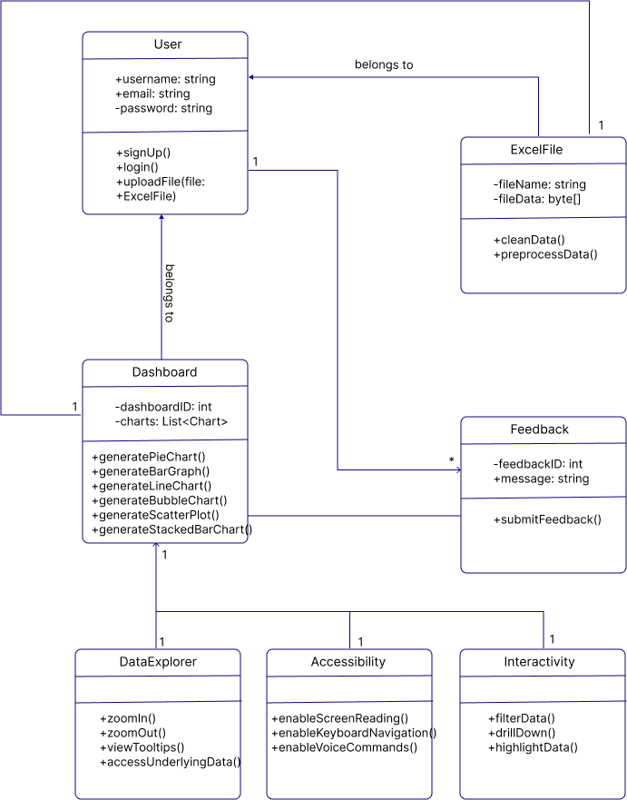

# ER Diagram(s)

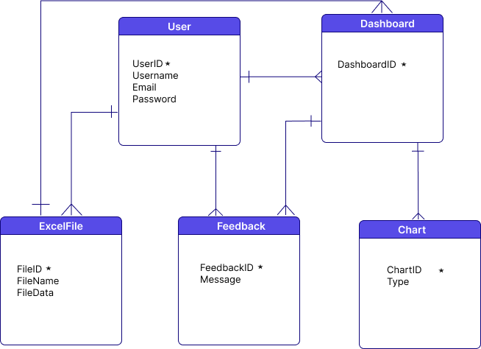

**Sequence Diagram(s)**

1. **User Registration and Authentication: -**

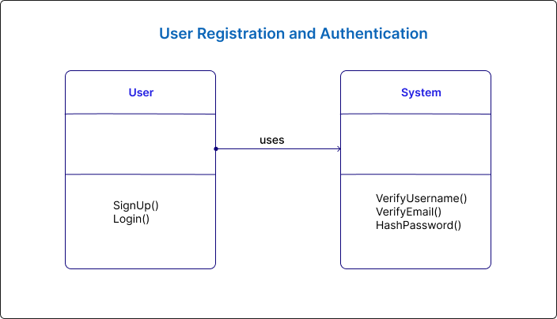

1. **User Login: -**

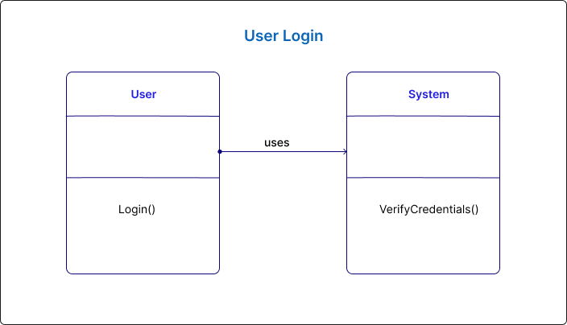

1. **File Upload: -**

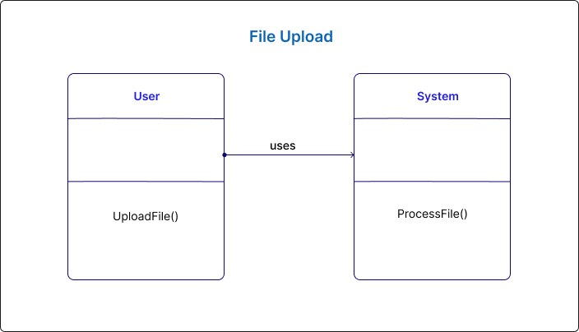

1. **Data Cleaning and Preprocessing: -**

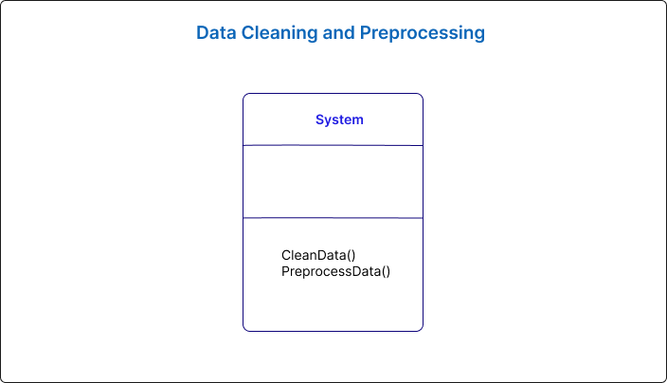

1. **Dashboard Creation and Customization: -**

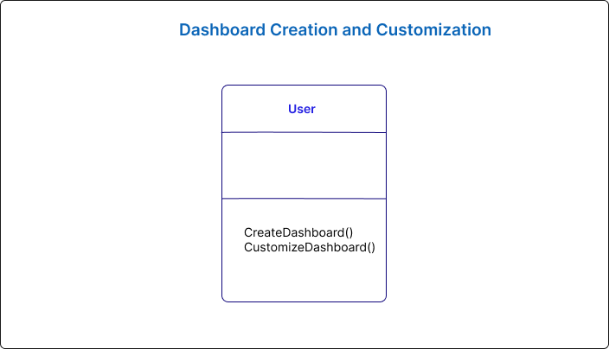

1. **Chart Generation: -**

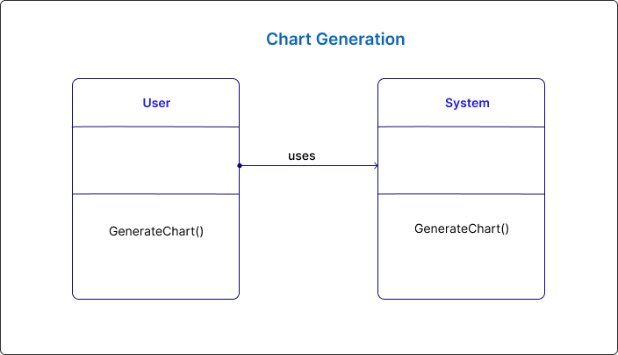

1. **Data Exploration: -**

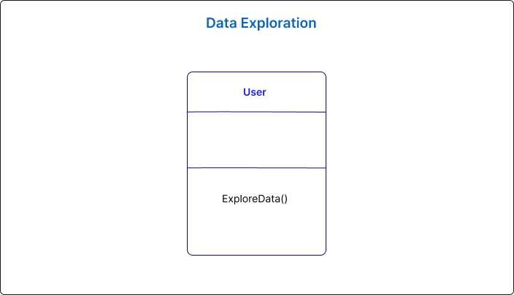

1. **Interactivity within Dashboards: -**

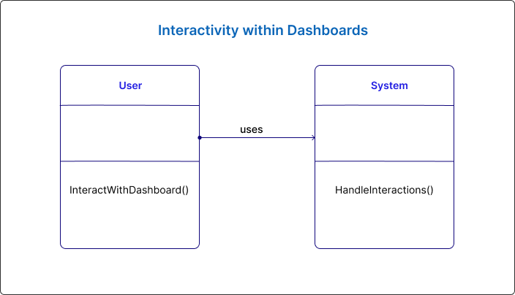

1. **Accessibility Features: -**

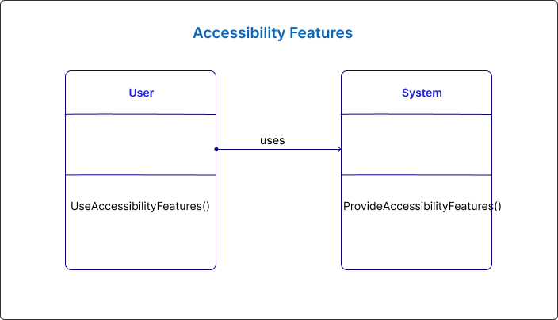

1. **History Features:**

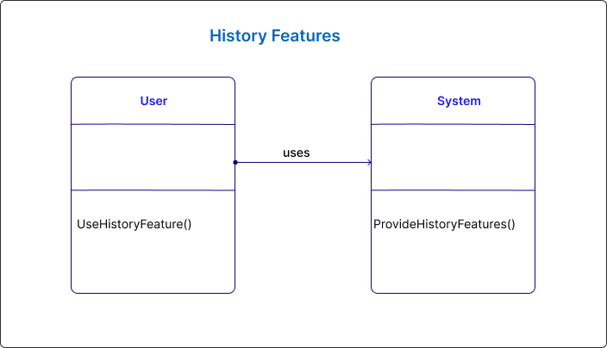

1. **Voice Command:**

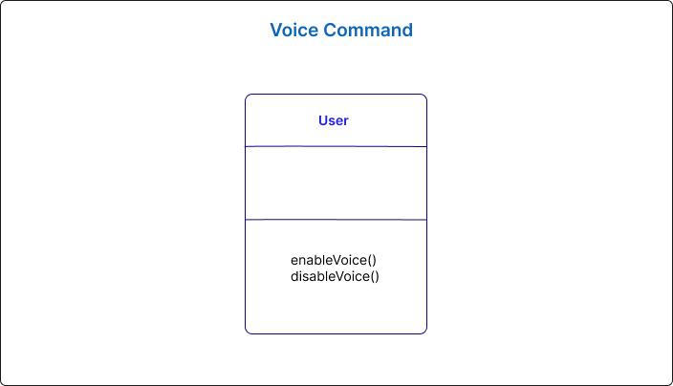

1. **Logout Features:**

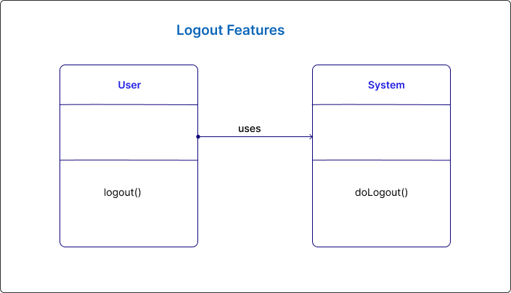

# Design Rationale

### User Registration and Authentication:

* + **Design Decision**:
    - Utilized a single "User" class to handle user registration and authentication.
    - Implemented methods like **SignUp()** and **Login()** to encapsulate the registration and login processes.

### Rationale:

* + - **Single Responsibility Principle (SRP)**: By having a dedicated "User" class, we ensure that user-related functionalities are encapsulated in one place. This promotes clean, modular code.

### Relationships:

* + - The "User" class interacts with the "System" for verification and hashing of credentials.

### File Upload:

* + **Design Decision**:
    - Introduced an "ExcelFile" class to manage uploaded files.

### Rationale:

* + - **Separation of Concerns**: This class provides a clean separation between handling uploaded files and other user-related functionalities.

### Relationships:

* + - The "Dashboard Page" interacts with the "ExcelFile" class to initiate the file upload process.

### Data Cleaning and Preprocessing:

* + **Design Decision**:
    - The data cleaning and preprocessing operations are handled by a dedicated module within the "System".

### Rationale:

* + - **Modularization**: Separating data cleaning and preprocessing ensures that each component has a clear responsibility, making the system more

maintainable.

### Dashboard Creation and Customization:

* + **Design Decision**:
    - Introduced a "Dashboard" class to manage the creation and customization of dashboards.

### Rationale:

* + - **Encapsulation**: This class encapsulates the logic for creating and customizing dashboards, promoting clean, organized code.

### Relationships:

* + - The "User" interacts with the "Dashboard" class to create and customize dashboards.

### Chart Generation:

* + **Design Decision**:
    - Introduced a "Chart" class to handle the generation of different types of charts.

### Rationale:

* + - **Abstraction**: This class abstracts the process of chart generation, allowing for easy extension with additional chart types in the future.

### Relationships:

* + - The "Dashboard" class interacts with the "Chart" class to generate the desired type of chart.

### Feedback Submission:

* + **Design Decision**:
    - Introduced a "Feedback" class to capture user feedback messages.

### Rationale:

* + - **Separation of Concerns**: This class isolates feedback-related functionalities from other aspects of the system, ensuring a focused and maintainable codebase.

### Relationships:

* + - The "Feedback Page" interacts with the "Feedback" class to capture and store feedback messages.

### Data Exploration:

* + **Design Decision**:
    - Included data exploration features directly within the system.

### Rationale:

* + - **User Experience**: Providing tools for data exploration within the system enhances the user experience and promotes a more comprehensive understanding of the data.

### Interactivity within Dashboards:

* + **Design Decision**:
    - Assumed interactivity features within dashboards to allow users to interact with data.

### Rationale:

* + - **User Engagement**: Enabling interactivity enhances user engagement with the visualizations, making the system more dynamic and informative.

### Accessibility Features:

* + **Design Decision**:
    - Introduced an "Accessibility" class to handle accessibility features within the dashboard.

### Rationale:

* + - **Inclusivity**: Providing accessibility features ensures that the system is usable by individuals with visual impairments, promoting inclusivity.

### Voice Activation:

* + **Design Decision**:
    - Assumed the inclusion of a "Voice Activation" service for user interaction.

### Rationale:

* + - **Enhanced Accessibility**: Voice activation provides an alternative mode of interaction, further enhancing accessibility for users.

### Overall Rationale:

* + **Scalability and Extensibility**:
    - By designing the system with clear class responsibilities and interactions, we create a foundation that can be extended with additional features and functionalities in the future.

### Modularity and Maintainability:

* + - Each class encapsulates specific functionalities, promoting modularity and making it easier to maintain and update the codebase.

### User-Centric Design:

* + - The design choices prioritize user experience, providing features for data exploration, interactivity, accessibility, and voice activation.

### Adherence to Design Principles:

* + - The design adheres to principles like Single Responsibility Principle (SRP), Separation of Concerns, and Encapsulation, promoting clean, organized, and maintainable code.

This design rationale reflects a thoughtful approach to meet the project's requirements and objectives, ensuring a robust and user-friendly "Sales Insights" application.

# Information Architecture Diagram

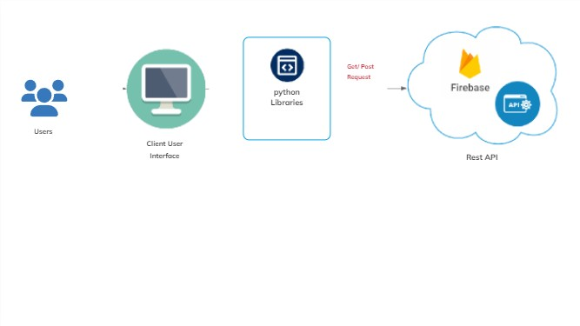

**User Interface Wireframe(s)/Screenshot(s)**

## Colours:

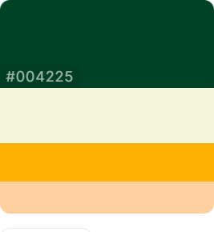

#004225 #F5F5DC #FFB000 #FFCF9D

## Registration Page:

This page will allow user to register to our sales insights website.

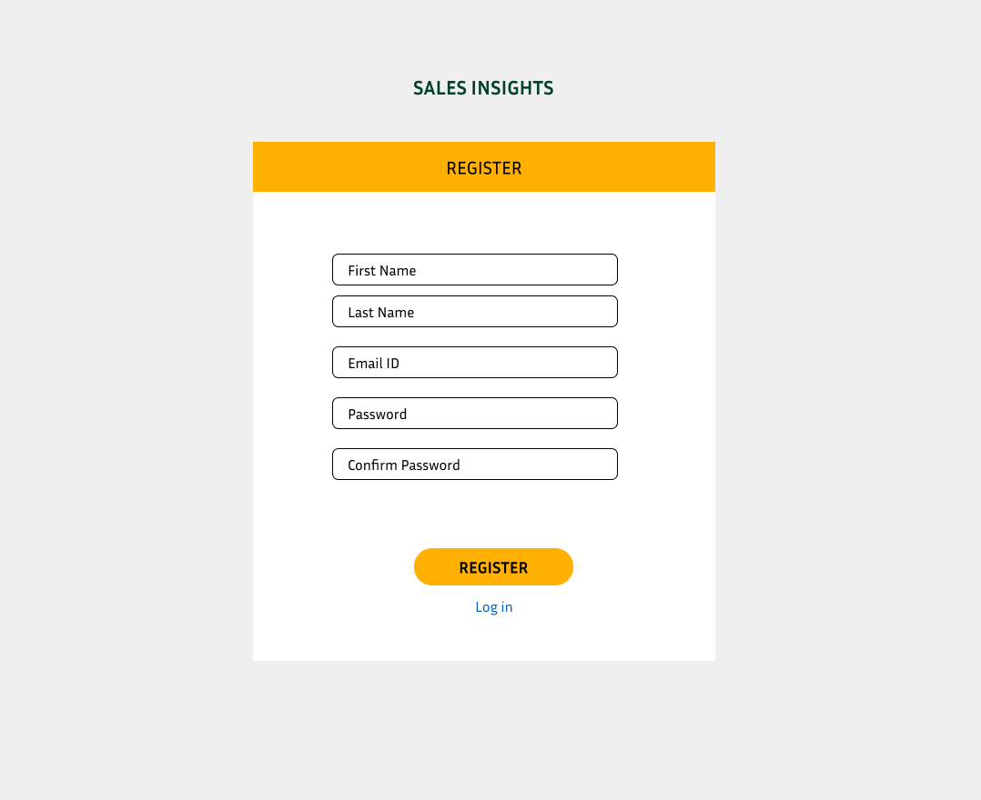

## Login Page:

When we will have registered on the website then we can login otherwise we will need to do registration. This page will allow to login to user on our website.

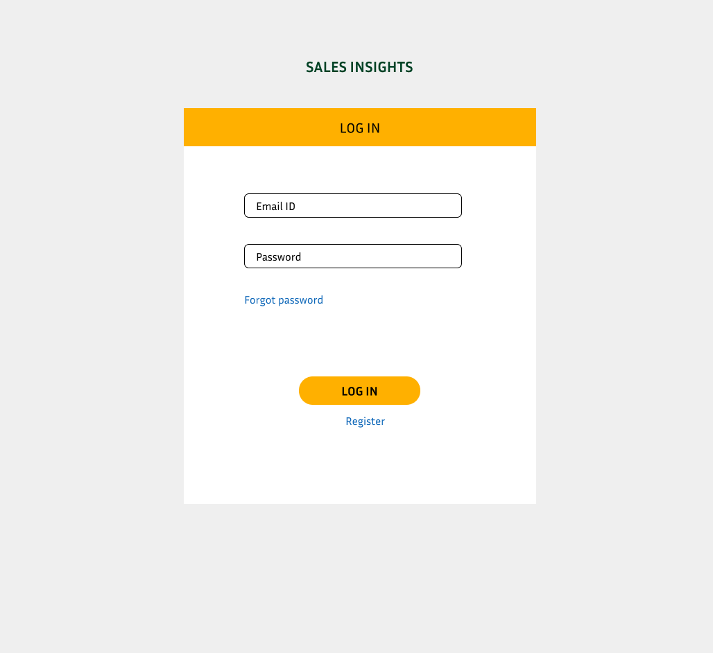

## Login Success Page:

When we will correctly put our info in input box then it shows the “ Login successfully ”.

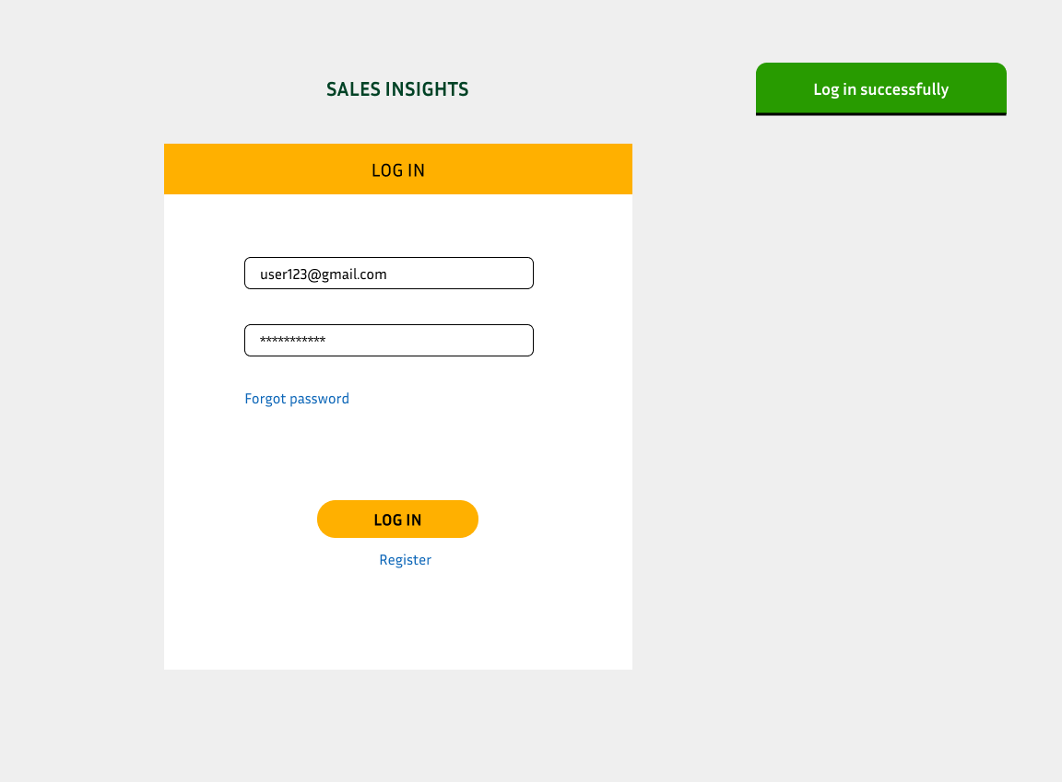

## Dashboard Page:

This page is dashboard page. It has multiple option to do. We can upload a file, give a feedback, log out and change our setting.

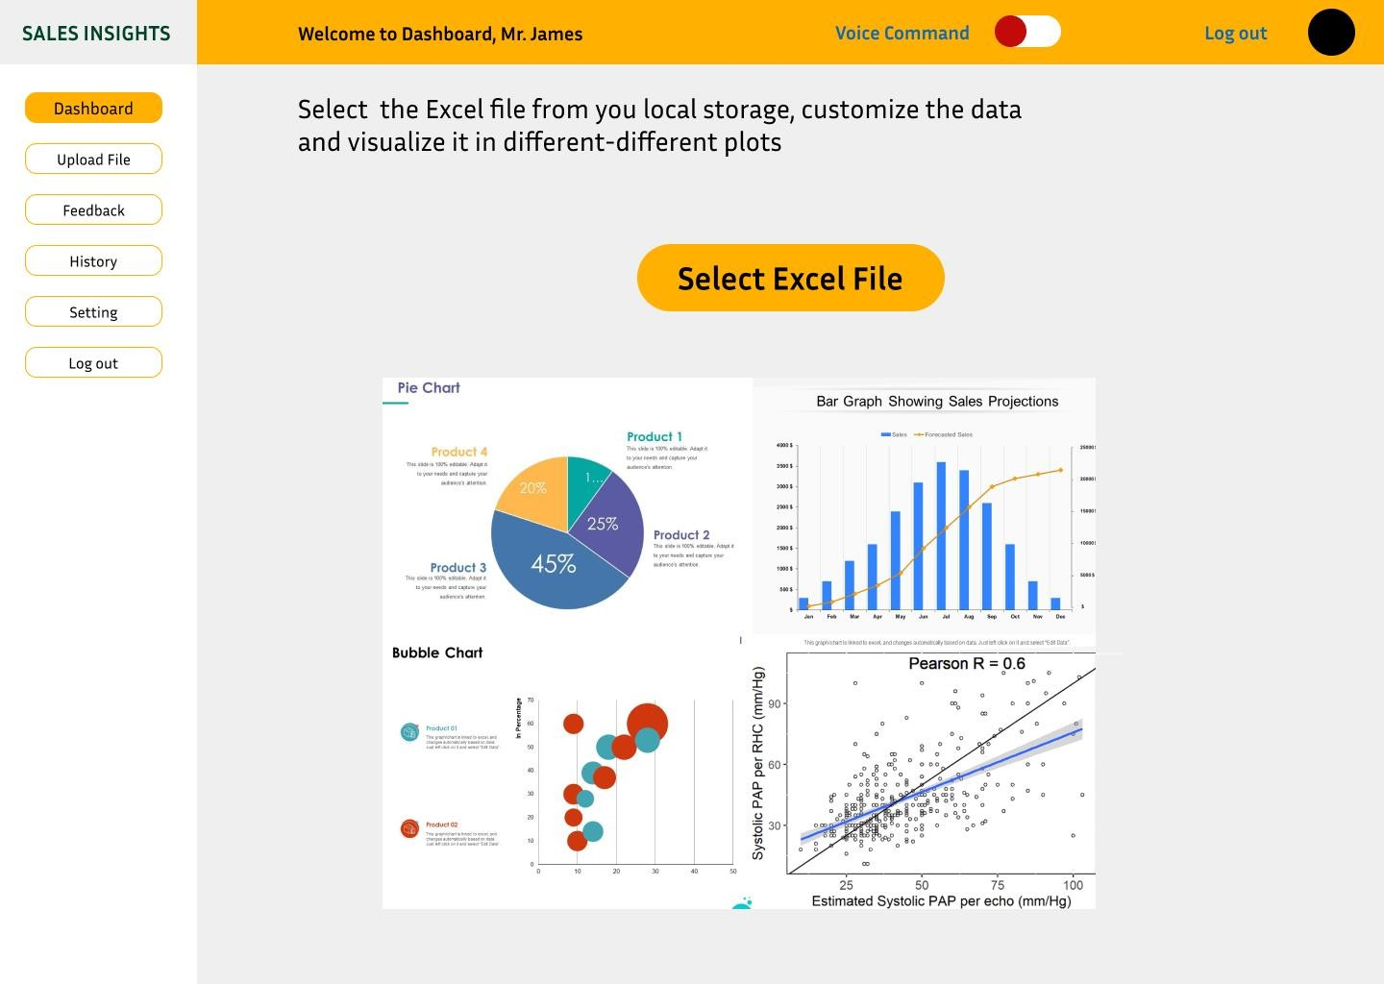

## File Selection Page:

When we will click on select excel file or upload file button then it give that interface and we can choose file from our device.

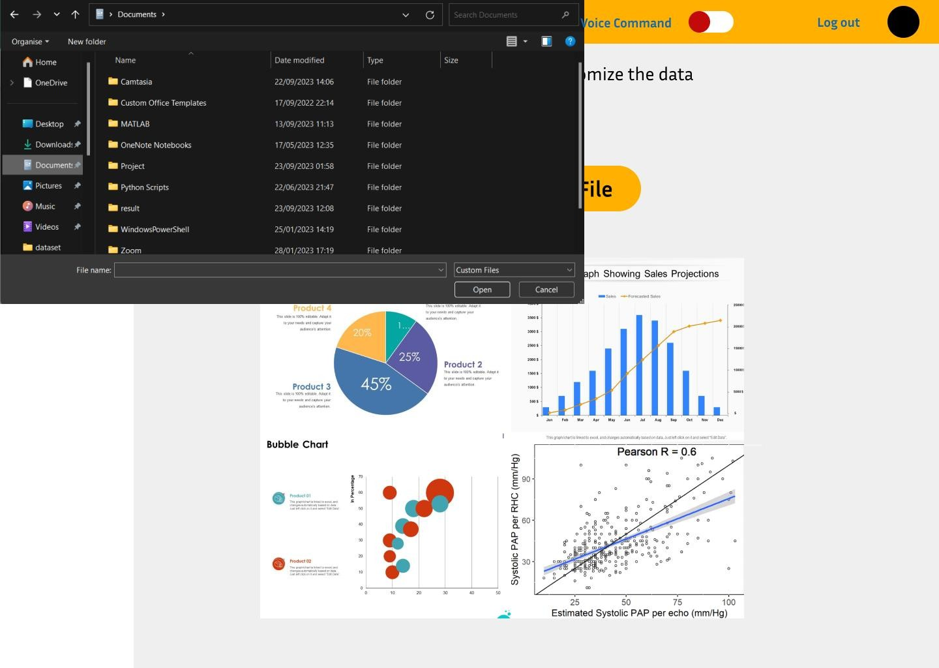

## Data Process Page:

When we will select the file then it shows the data of that file . It will give options, we can either clean that data or process that data.

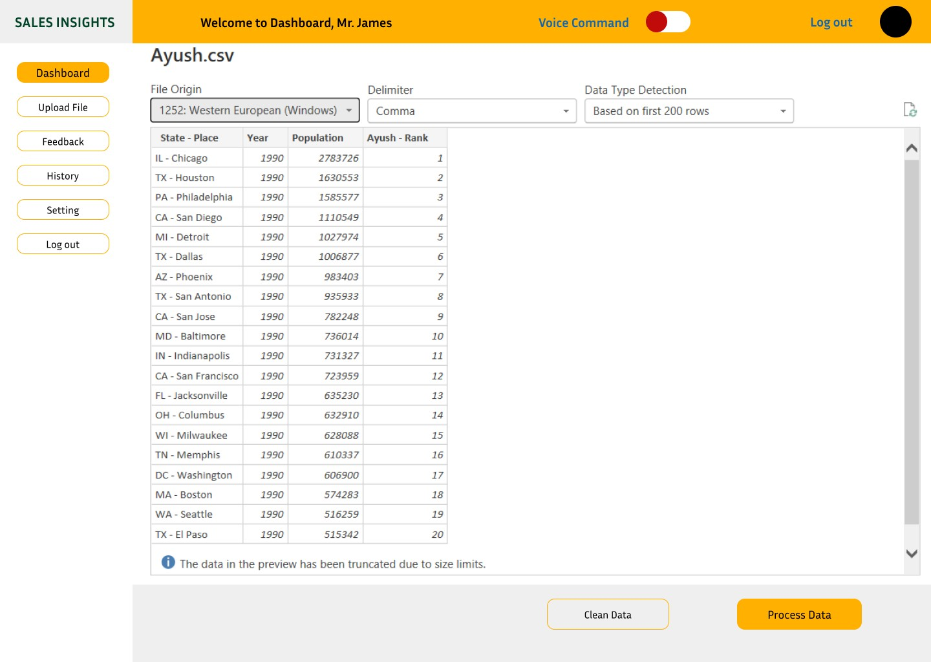

## Data Explorer:

This page will allow to user to explore the data and do some editing for generating the charts.

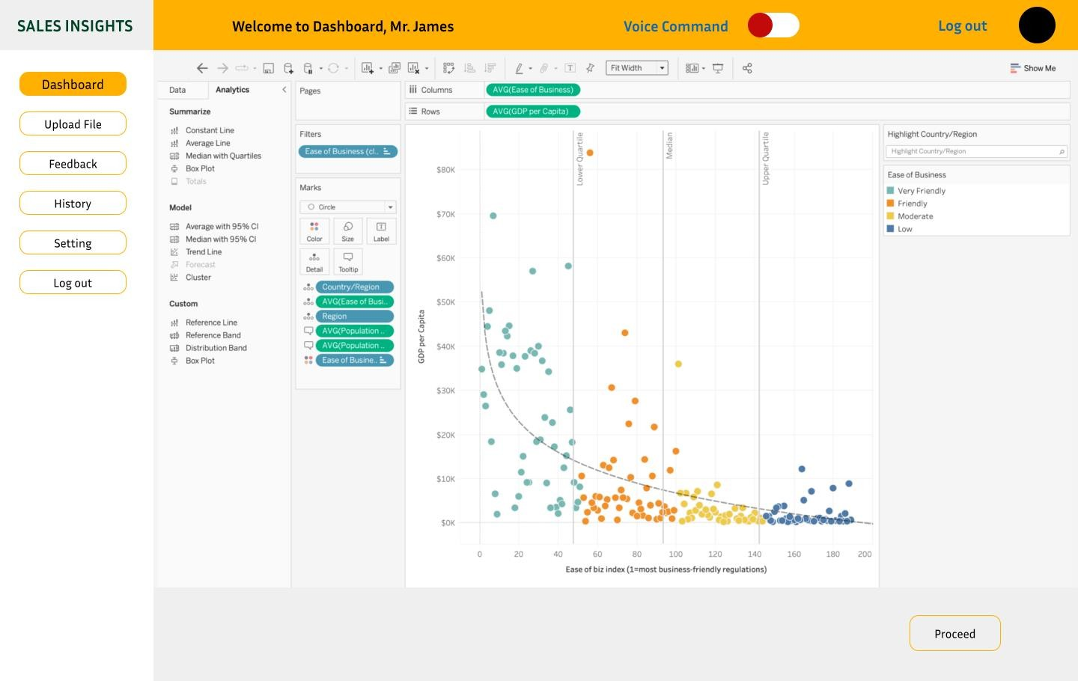

## Charts Generating Page:

* + **Pie chart:**

When we will click on pie chart button then it generates the pie chart according to the provided data which we cleaned and proceed

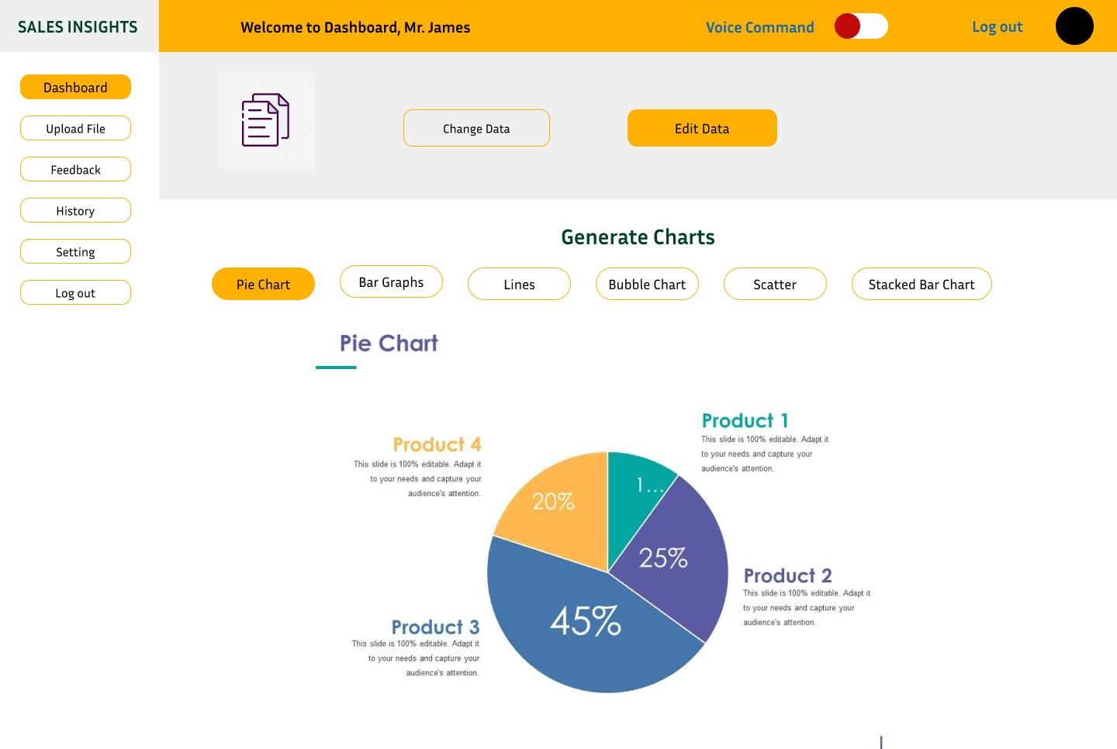

## Bar Graph:

When we will click on bar graph button then it generates the bar graph according to the provided data which we cleaned and proceed.

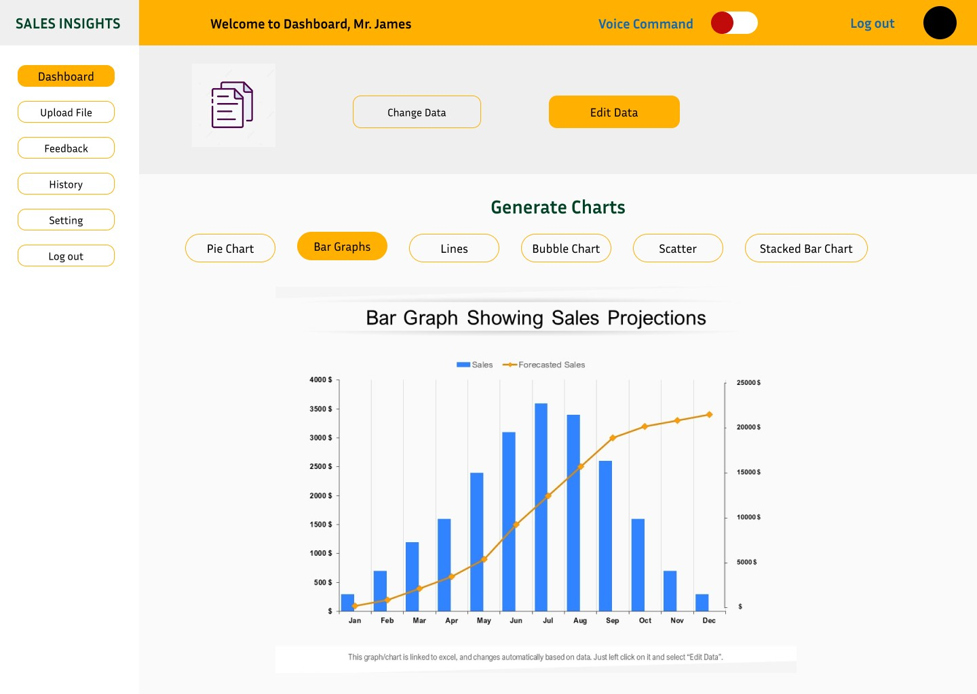

## Bubble Chart:

When we will click on bubble chart button then it generates the bubble chart according to the provided data which we cleaned and proceed.

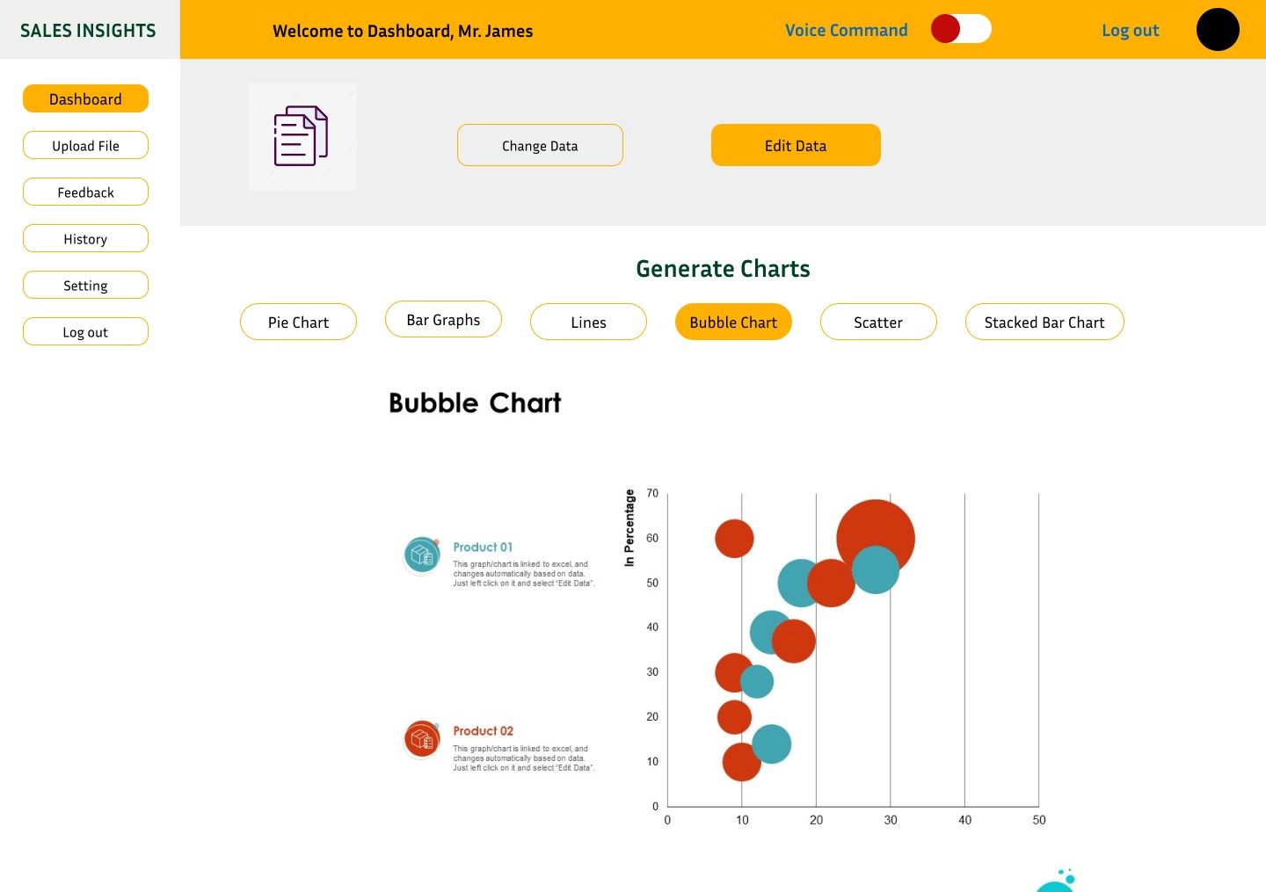

## Lines Graph:

When we will click on lines button then it generates the lines chart according to the provided data which we cleaned and proceed.

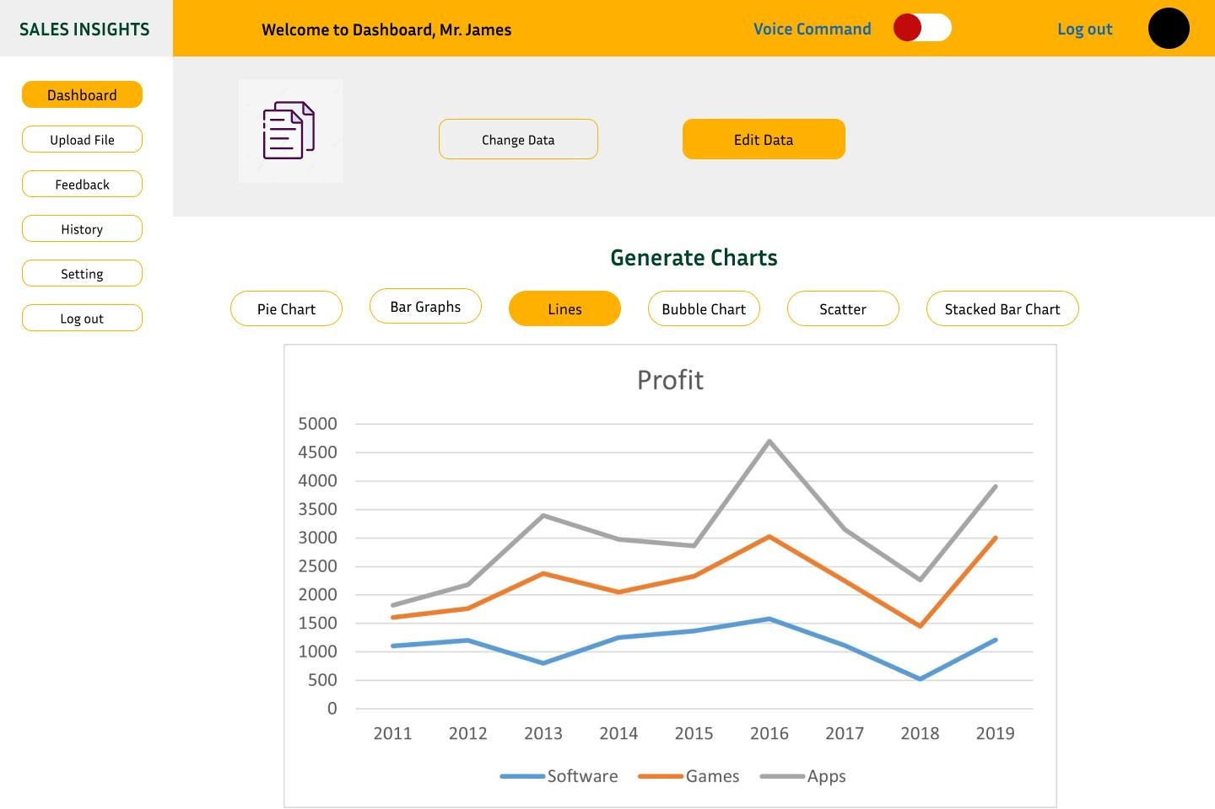

## Scatter Charts:

When we will click on scatter chart button then it generates the scatter chart according to the provided data which we cleaned and proceed.

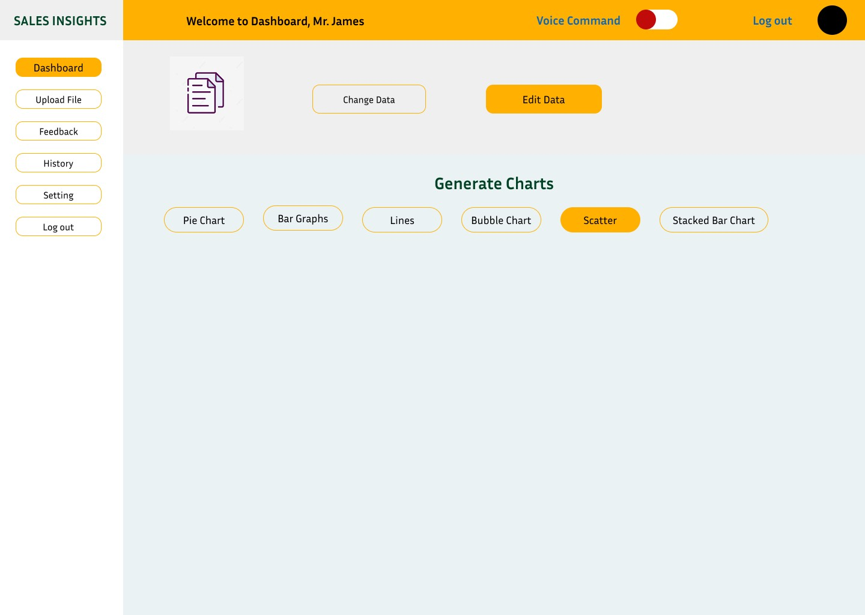

## Scatter Bar Chart:

When we will click on scatter bar chart button then it generates the scatter bar chart according to the provided data which we cleaned and proceed.

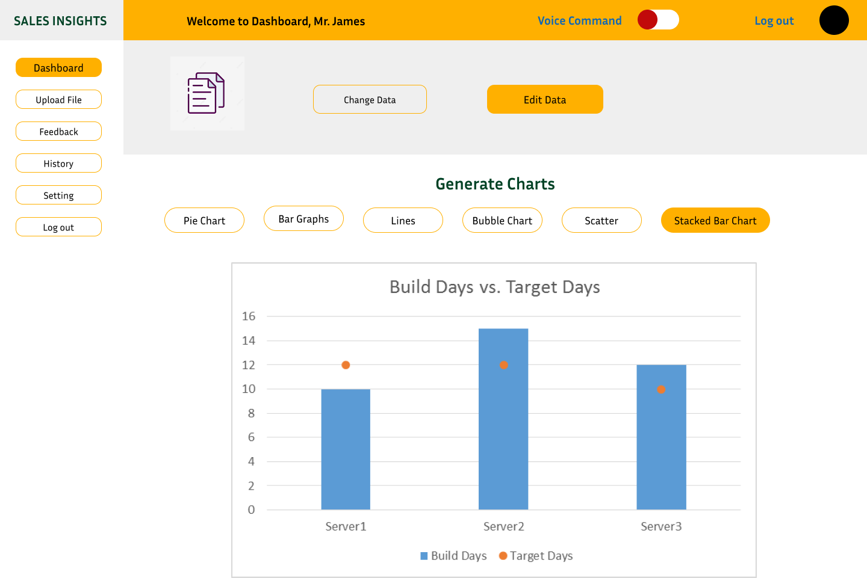

## Feedback Page:

This page will allow to user to give feedback. User can give feedback about the generated charts, data accuracy and entire website.

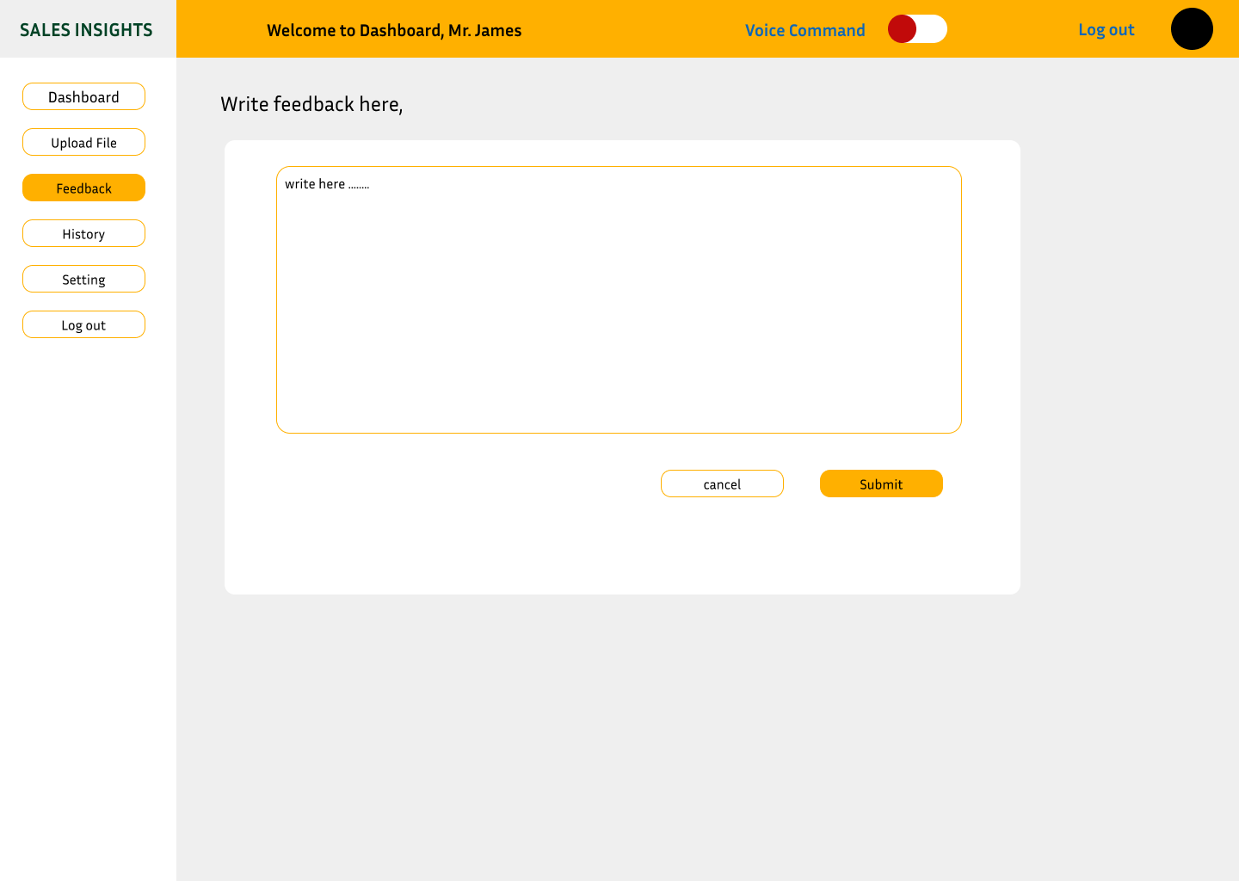

## Voice command:

The give button will allow to user to unable and disable the voice command.

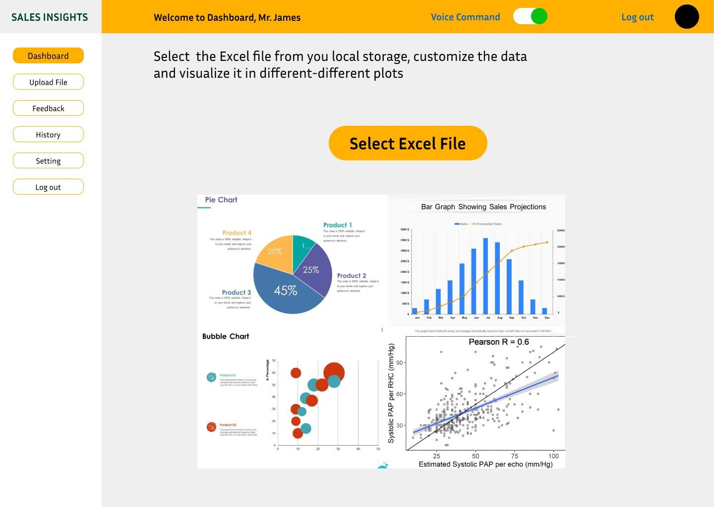

## history recent file:

This page will allow to store the recent project which will be done in future and for other purpose.

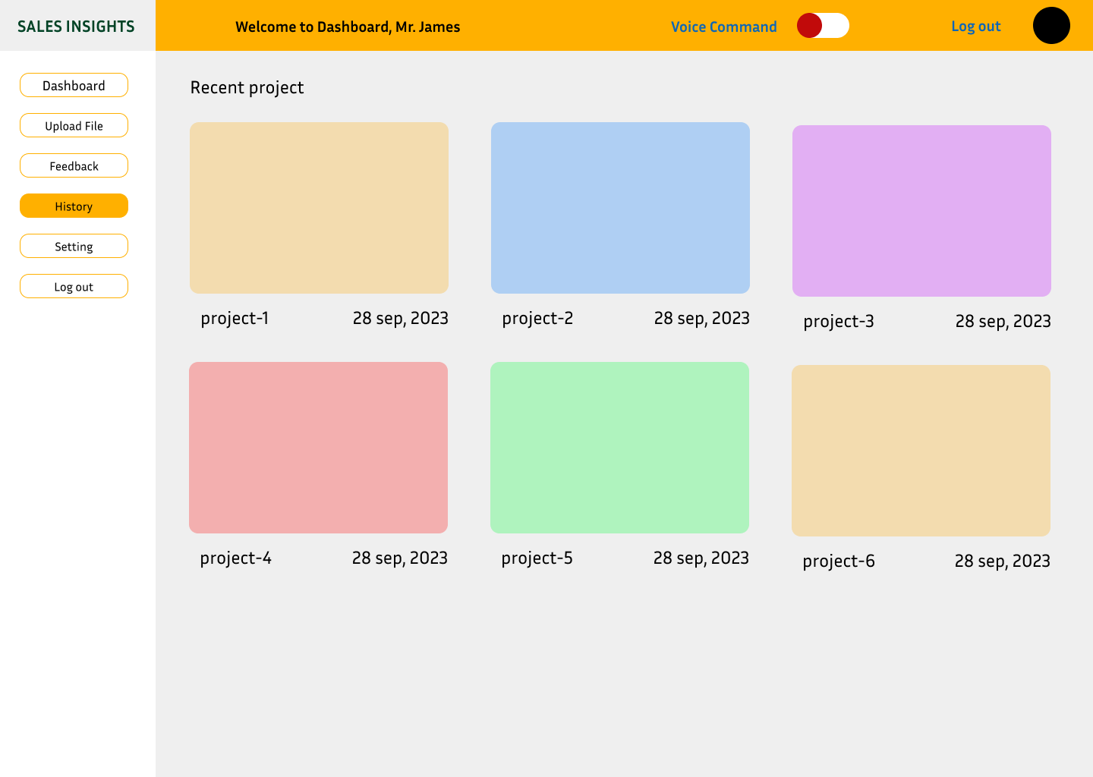

## Log out Page:

This page will allow to user to log out from our website. They will have two options: yes or no.

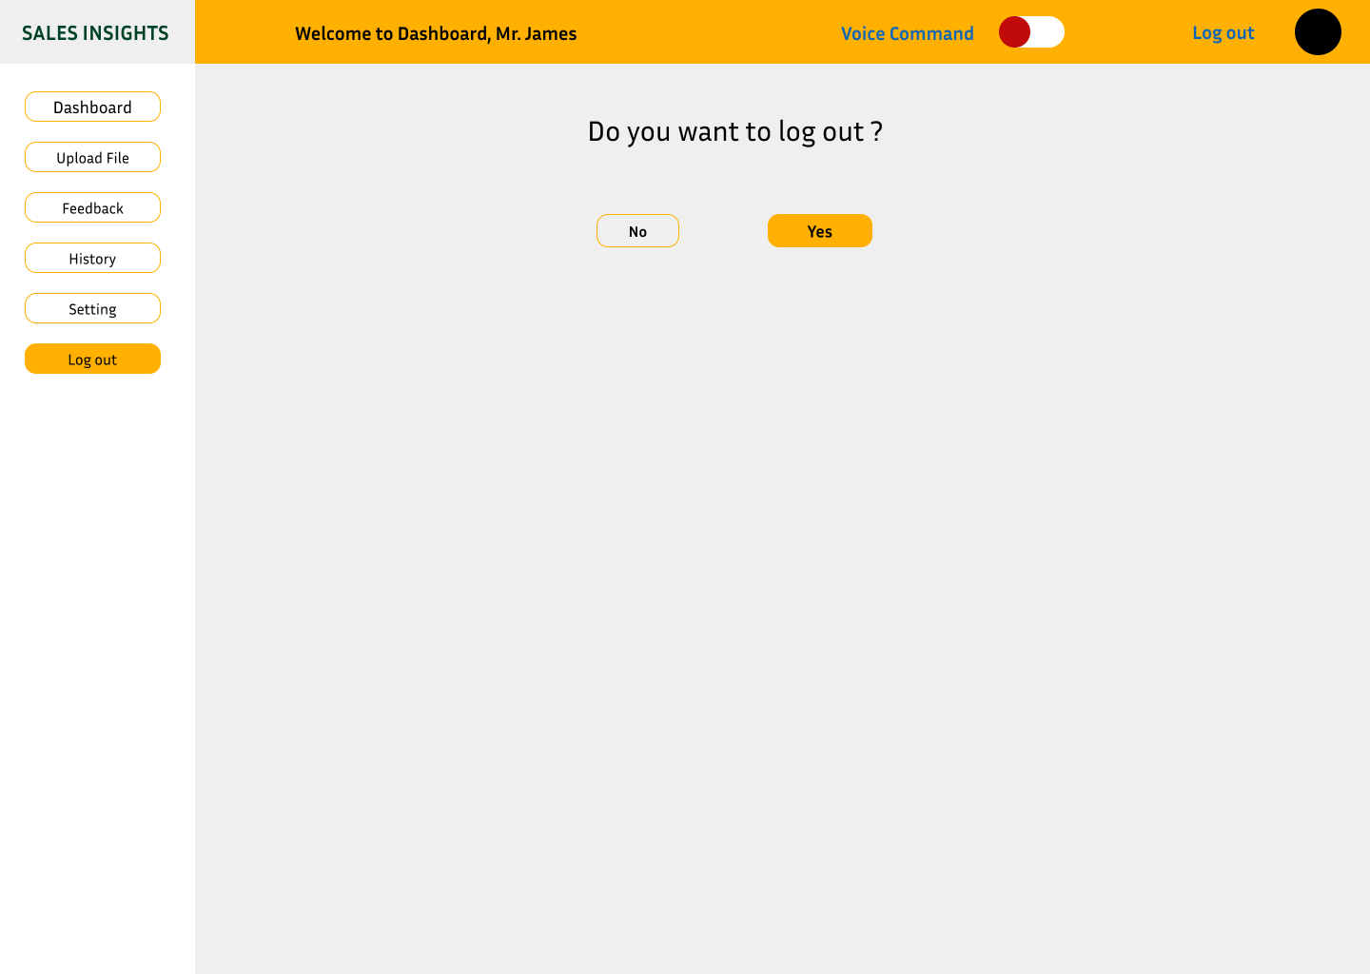

**INDIVIDUAL CONTRIBUTIONS**

|  |  |  |
| --- | --- | --- |
| **NAME** | **STUDENT _ID** | **CONTRIBUTION** |
| Gowri Priya Pulagam | 11710373 | Involved in discussing about the project and worked on Class Diagram , Design Rationale. Given inputs for whole project and also participated in editing logo and file. |
| Prem Gladsone Kanaparthi | 11710378 | Involved in discussing about the project and worked on Sequence Diagram. And also given inputs from my side also for whole project and participated in editing logo and file with my team members. |
| Manish Raghunathareddy | 11657375 | I have also Involved in discussing about the project and worked on Information Architecture diagram and given some inputs regarding to Sequence Diagram. Worked on UI diagrams . And also given inputs from my side also for whole project and participated in editing logo and file with my team members. |
| Divyasree Sandineni | 11653172 | I have also Involved in discussing about the project and worked on ER Diagram and given some inputs regarding to Class Diagram. Worked on Figma. And also given inputs from my side also for whole project and participated in editing logo and file with my team members. |
| Harshavardhan Thotakura | 11718816 | I have also Involved in discussing about the project and worked on Design Rationale and given some inputs regarding how to make diagrams in figma. And also given inputs from my side also for whole project and participated in editing logo and file with my team members. |